**Git Assignments**

**Mod 2, Git Assignment:1**

**To Do :**

● Create a new folder

● Put the following files in the folder ○ Code.txt ○ Log.txt ○ Output.txt

● Stage the Code.txt and Output.txt files

● Commit them

● And finally push them to github

**Solution :-**

mkdir test // creating a directory/folder

cd test //going inside the directory

//Making the required files :

touch code.txt

touch log.txt

touch output.txt

git init-m "code.txt output.txt pushed"

git add code.txt output.txt //Staging Code and output.txt(not committed yet)

git commit -m "code.txt output.txt committed" //commiting the two files,files ready to push

Pushing the files to Remote repository i.e. GitHub -

//First, connecting to github repository via ssh- "git remote add origin <url of repo>"

git remote add origin git@github.com:sinhatushar17/Ipt-d.ops-Assignments.git //origin is set.

Configuring github :

cd //out of test dir.

cd .ssh

ssh-keygen (pressed enter 3 times) //Generating key pair

ls //authorized_keys : id_rsa id_rsa.pub -

cat id_rsa.pub //now after entering this cat code "Public Key" was generated.

cd .. //out of .ssh

cd test

//we have top paste this Publlic Key on github.so that our authentication method is proper. -> going to github profoile >settings >ssh and gpg keys>new ssh key >Pasted the ssh key.

git push origin master //Pushed files to our repo, now verifying on github in my "Ipt- d.ops-Assignments" Repository _ two files present.

git push origin master //Pushed files to our repo, now verifying on github in my "Ipt- d.ops-Assignments" Repository _ two files present.

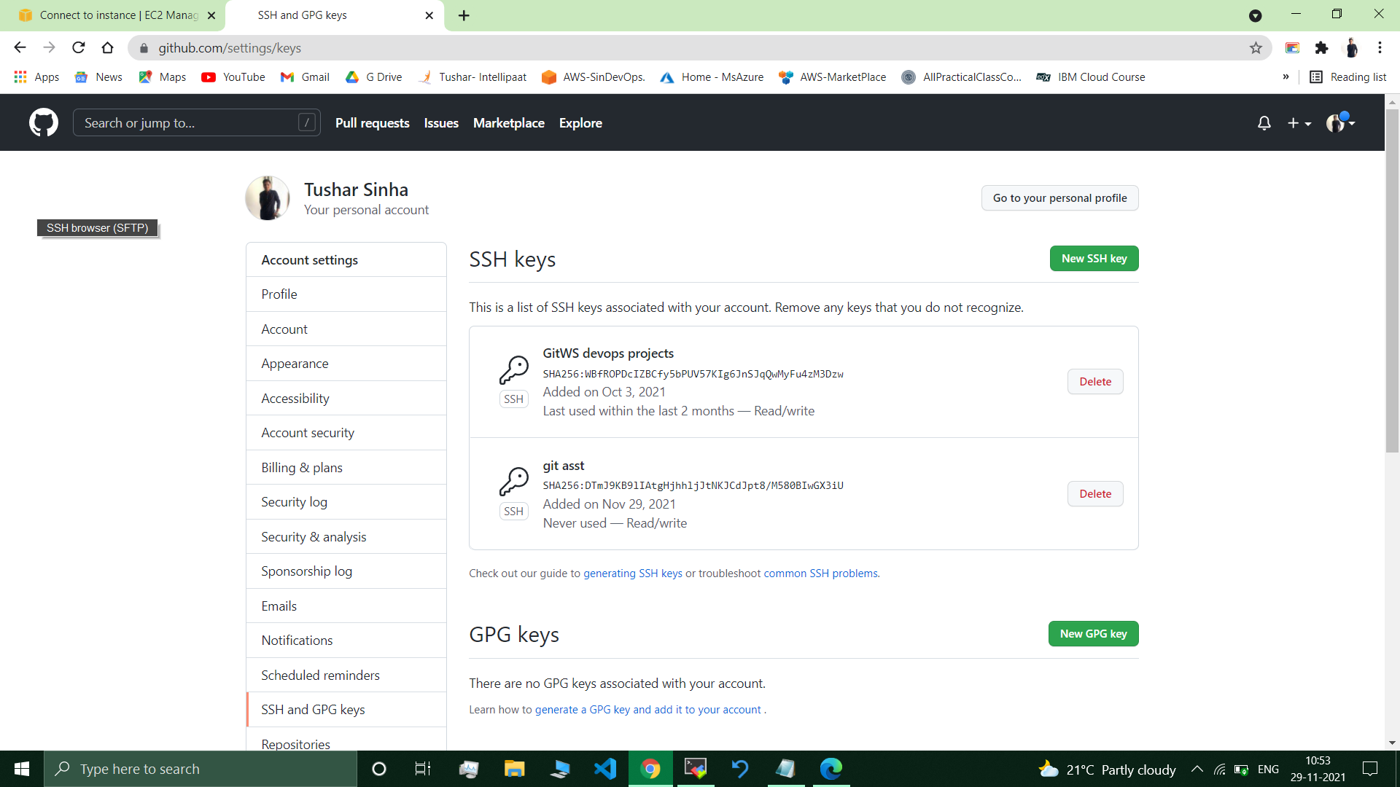

git push origin master //Pushed files to our repo, now verifying on github in my "Ipt- d.ops-Assignments" Repository _ two files present.

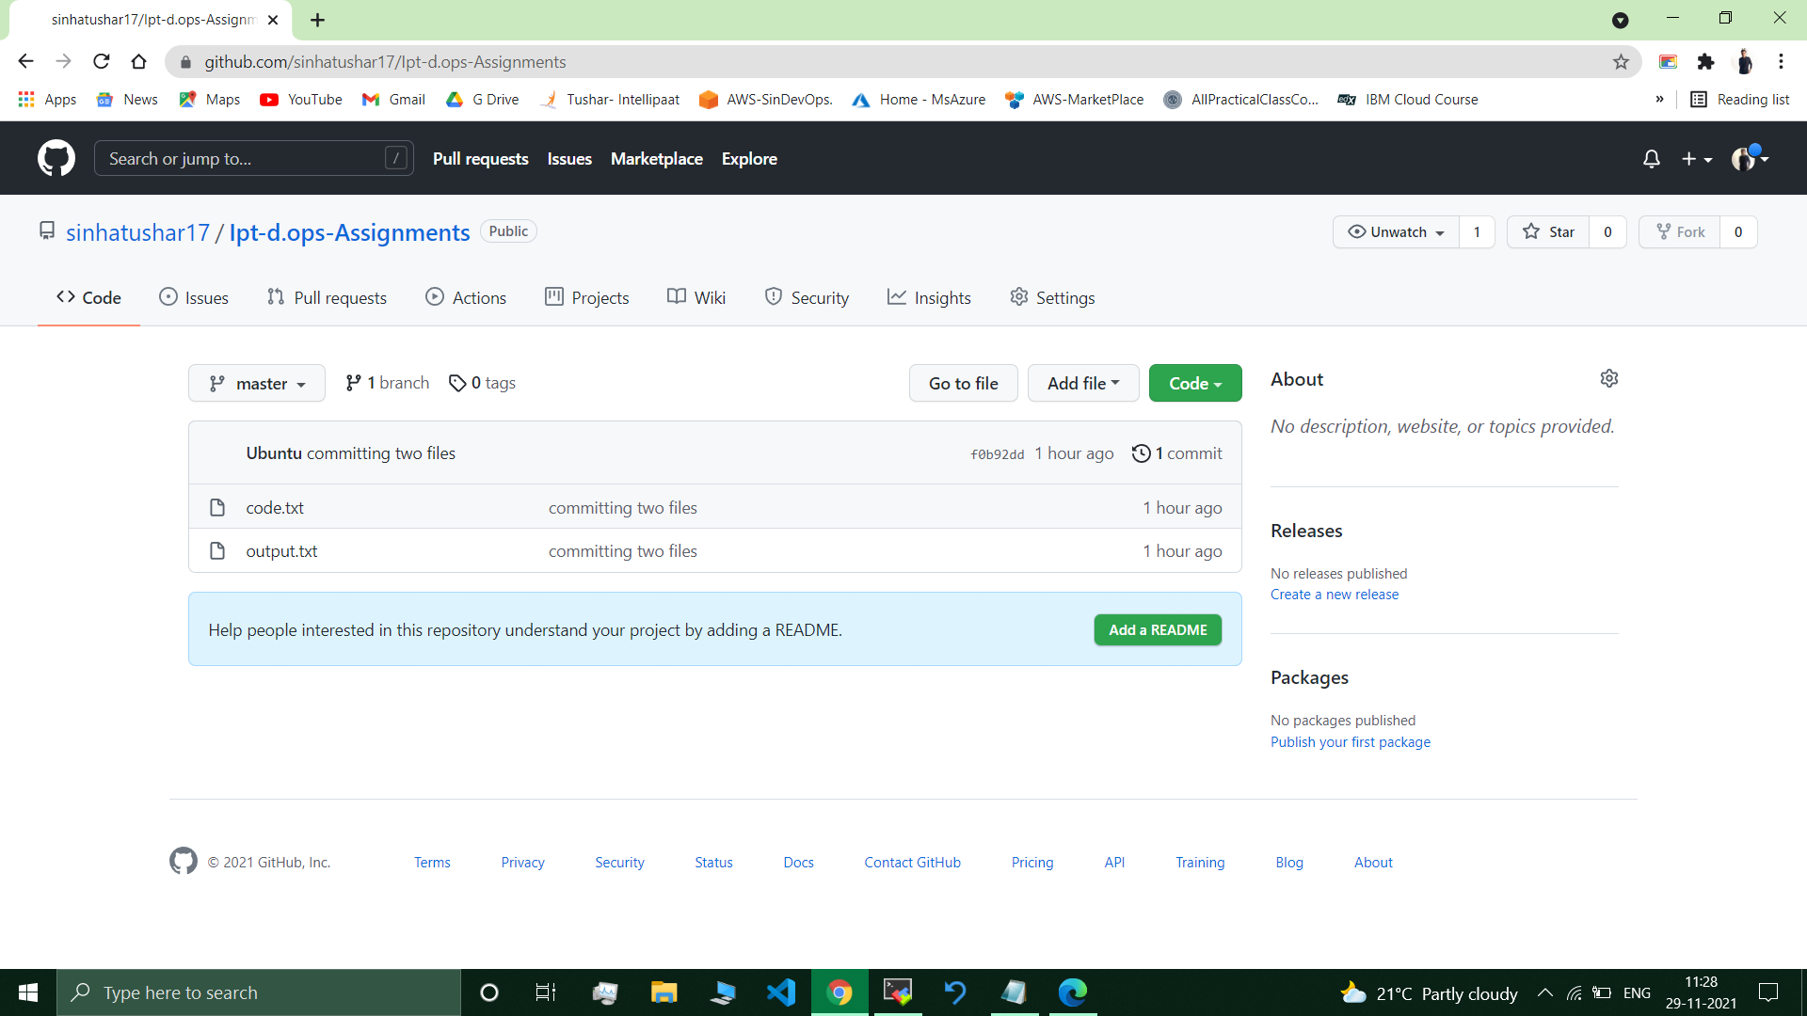

**Submitted By : Tushar Sinha**

**Email ID :** [**sinhatushar17@gmail.com**](mailto:sinhatushar17@gmail.com)

**Enrolled in the “DevOps Architect Master’s Training Program”**